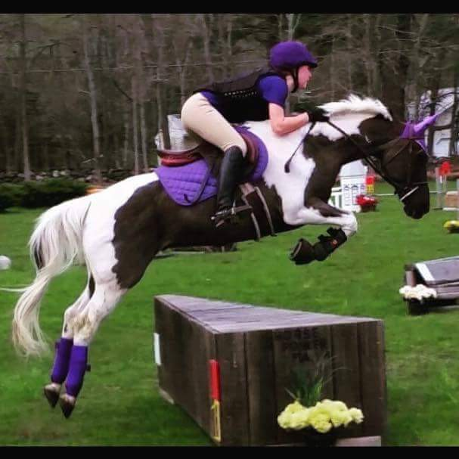
Horse Stables in UConn Area
B=BOARDING, R=RIDING LESSONS, S=SELLS HORSES, P=PUBLIC TRAILS
L=LEASING, T=TRAINING, E=EVENTING

ASHFORD
Narnia Stables
Meg and Luther Brauch
210 Wormwood Hill Rd
Ashford, CT 06278
(860) 450-9504
https://narniastables.com/
narniastablesevents@gmail.com
B, T, R (to people on their own horses)

BOLTON
C and M Farms Equestrian Center
Karen Picard
284 West Street
Bolton, CT 06040
(860) 982-1781
https://candmequestrian.com/
cmfarmsequestrian@gmail.com
B,R,L,T, S

CHAPLIN
Ireland Farms
22 North Bear Hill Rd.
Chaplin, CT 06235
(860) 455-0462
B, R, T, S (Breeding too!)

COLUMBIA
Gates Estates
Gina Gates
46 Macht Road
Columbia, CT 06237
(860) 933-3394
B, R, S, L, T, E

Grace Brook Farm
Rochelle McPherson
266 Route 87,
Columbia, CT 06237
(860) 228-5047
rochelle.mcpherson@yahoo.com
B, R, S, T

More On Back

Infinity Farm
Melissa Lussen
196 Pine Street
Columbia, CT 06237
(860) 228-0764
Cell: (860) 659-7709
www.infinityfarmllc.com
B, R, S, L, T

COVENTRY
ABF Equine
257 Judd Rd.
Coventry, CT 06238
(860) 944-2527
B, R, S, L, T, E

Connecticut Equestrian Center
Athene Von Hirschberg
220 Talcott Hill Rd.
Coventry, CT 06238
(860) 942-3942
https://www.ctequestrian.com/
athene@ctequestrian.com
B, R, L, T, E

Babcock Hill: Horses Natrually
577 Babcock Hill Rd.
Coventry, CT 06238
(860) 742-2667(Barn)
860-985-7611 (Cell)
www.babcockhill.com
B, R, T, E

EAST WINDSOR
Oak Meadow Farm
309 Scantic Road
East Windsor, CT 06088
(860) 306-7682
Facebook
B, R, S, T, L, E

HAMPTON
Cedar Rock Farms
146 Estabrooks Rd.
Hampton, CT 06247
(860) 334-0860
www.cedarrockfarm.com
B, R, S, P, L, T, E

HEBRON
Windcrest Farm
344 Gilead Street
Hebron, CT 06248
(860) 944-3625
www.windcrestfarmct.com
B, R, S, L,T

LEBANON
Carbery Fields Farm
859 Beaumont Hwy.
Lebanon, CT 06249
860-208-6151
https://carberyfields.com/
lizcaron@carberyfields.com
R, T, B, E, S

Field of Dreams Farm
33 McCall Rd.
Lebanon, CT 06249
(860) 608-2793
liz.rogers@charter.net
B,T,R

Hidden Brook Stables
447 Waterman Rd.
Lebanon, CT 06249
(860) 377-8299
www.hiddenbrookstables.com
B,R,S,L,T

The Hill at Graywall Farms
724 Exeter Road
Lebanon, CT 06249
860-617-2262
thehillgf@yahoo.com
B, L, T

MANSFIELD
Foxfire Stables
85 South Bedlam Rd.
Mansfield Center, CT 06250
(860) 455-0739
www.foxfirestables.net
R, T, B, Dressage with Gretchen Geromin

SOMERS
Shallowbrook Equestrian Center
247 Hall Hill Rd.
Somers, CT 06071
(860) 749-0749
www.shallowbrook.com
B, L, R, S

WINDHAM
Indian Hollow Stables
397 Indian Hollow Road
Windham, CT 06280
(860) 456-0531
Facebook
B, R, L, T

Parish Hill Stables
63 Parish Hill Rd.
North Windham, CT 06256
(860) 456-2950
B, R, T

WILLINGTON
Magnolia Run Equestrian Center
34 Cemetery Road
Willington, CT 06279
(914) 774-0719
www.magnoliaruneqcenter.com
magnoliaruneqcenter@gmail.com
B, R, S, L, T, E

